# eBar Systems Installation Guide

Install .Net 4.5 Framework

Install SQL Express 2012

Installation of eBar Systems Database

Install eBar Systems Data Grabber Service (Not needed at the moment)

Install eBar Systems Data Grabber Console

Install eBar Systems Data Viewer

# Installing the .Net 4.5 Framework

The .Net Framework is a set of Windows libraries that programs can share to prevent developers from having to write their own libraries, reducing software size and increasing efficiency. Most computers have a version of the .Net Framework preinstalled to check what versions are installed please visit <http://msdn.microsoft.com/en-us/library/hh925568(v=vs.110).aspx> however 4.5 **MUST BE INSTALLED** for this application to work.

1. Go to <http://www.microsoft.com/net/downloads>

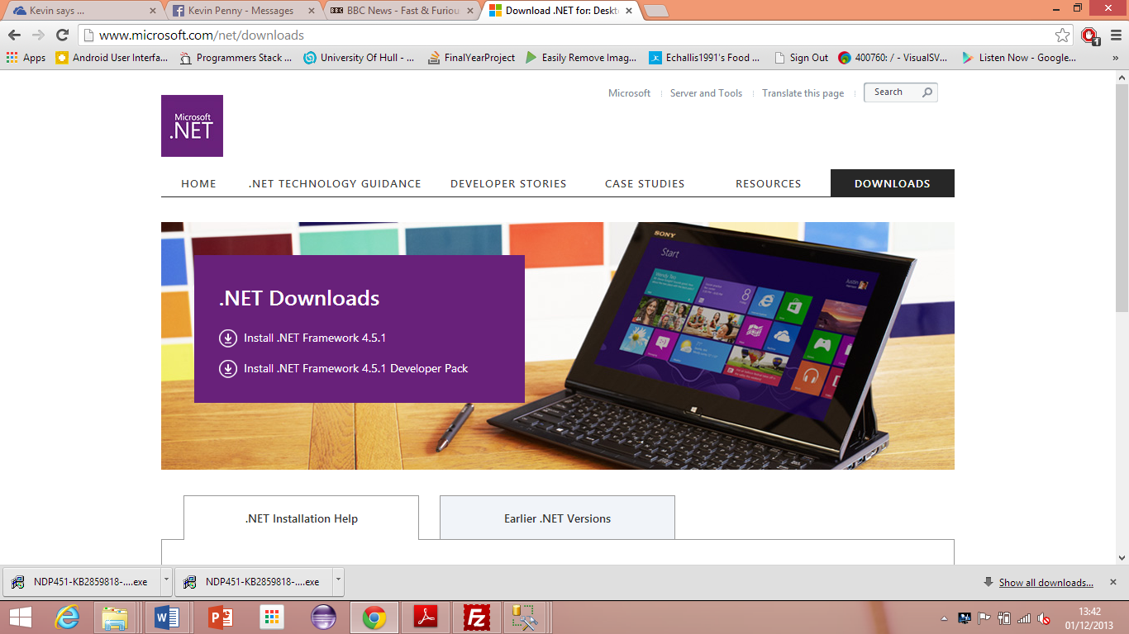

1. Click **Install .NET Framework 4.5.1**
2. Download will begin
3. Run through setup

# Installing SQL Express with Management Tools

SQL Express is a free version of Microsoft’s database software. There are a range of installations available so ensure that the correct version (according to this guide) is installed otherwise it may cause issues trying to view the database.

1. Visit <http://www.microsoft.com/en-gb/download/details.aspx?id=29062>

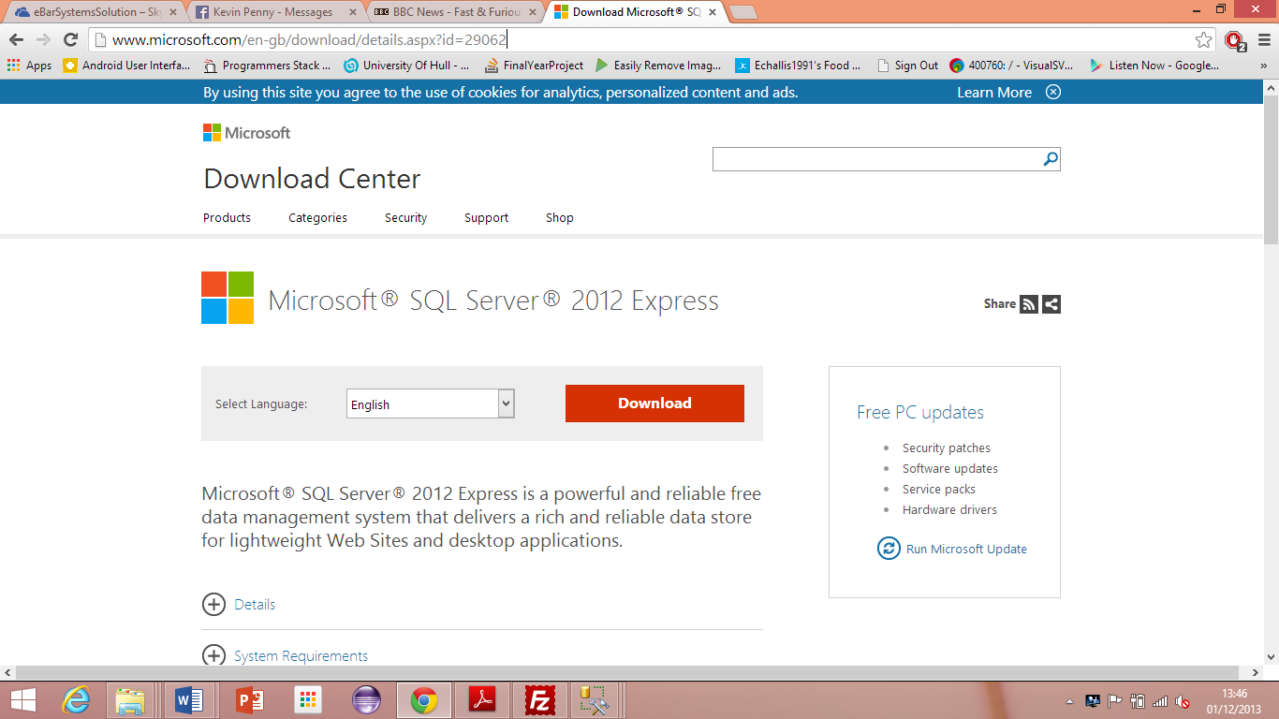

1. Click **Download**

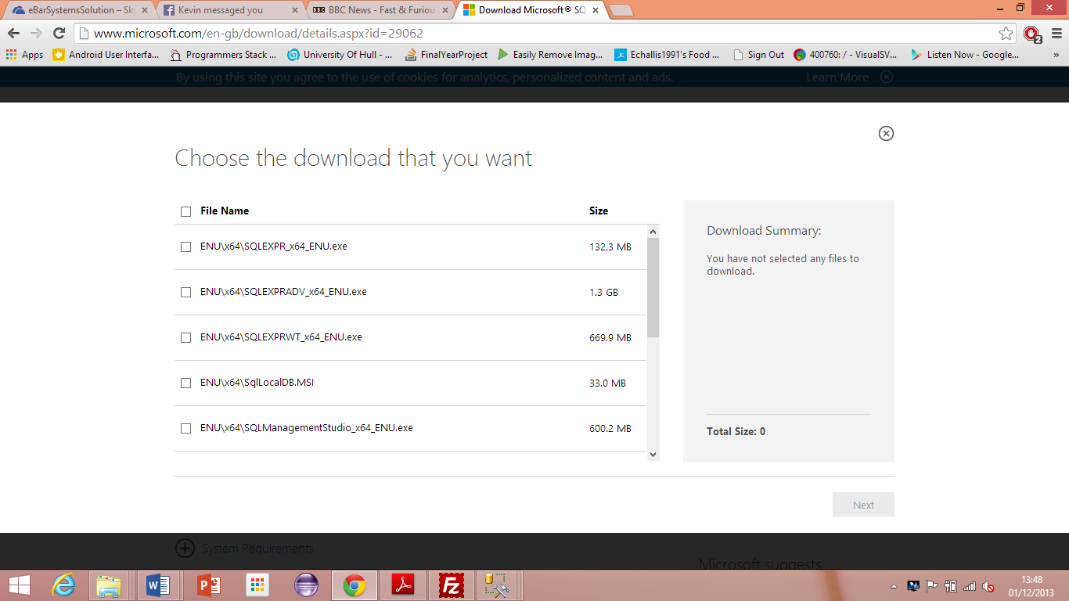

1. Select either **ENU\x86\SQLEXPRWT_x86_ENU.exe** or **ENU\x64\SQLEXPRWT_x64_ENU.exe** depending on whether your operating system is 32-bit (x86) or 64-bit (x64).
2. Once downloaded run the installation
3. **ENSURE ALL FEATURES ARE SELECTED AND INSTALLED  
   ENSURE MIXED AUTHENTICATION MODE IS ENABLED AND CREATE PASSWORD FOR SQL ADMIN**

# Installing eBar Systems Database

The eBar Systems Database uses stored procedures to write data to the database. This increases the security of the software and prevents SQL injection attacks therefore, it is often easier to restore the database from a blank copy of the original. Blank meaning all log data, all user ids, pump numbers etc are removed but the database setup and stored procedures will remain intact. The following steps demonstrate how to restore the eBar Systems Database. Fresh setup will be integrated into the final product so this may become irrelevant in future versions.

1. Open SQL Server Management Studio
2. Log in using either Windows Authentication or click the **authentication** dropdown and select **SQL Authentication** and enter the username “SA” with the password set during setup.

*SQL Authentication is recommended as it may be possible that the Windows account does not have sufficient database permissions resulting in errors running the software.*

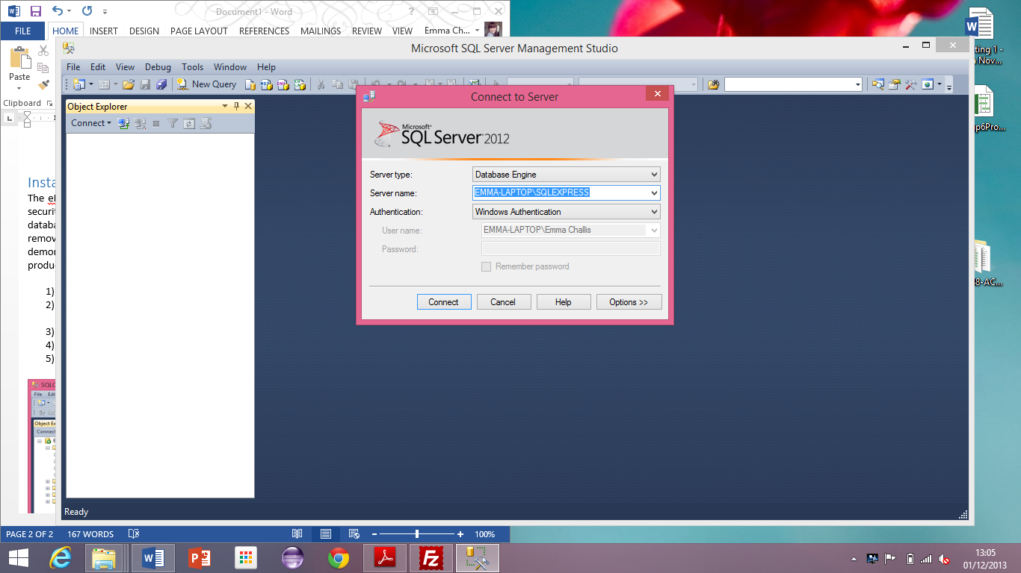

1. Right-Click **System Databases**

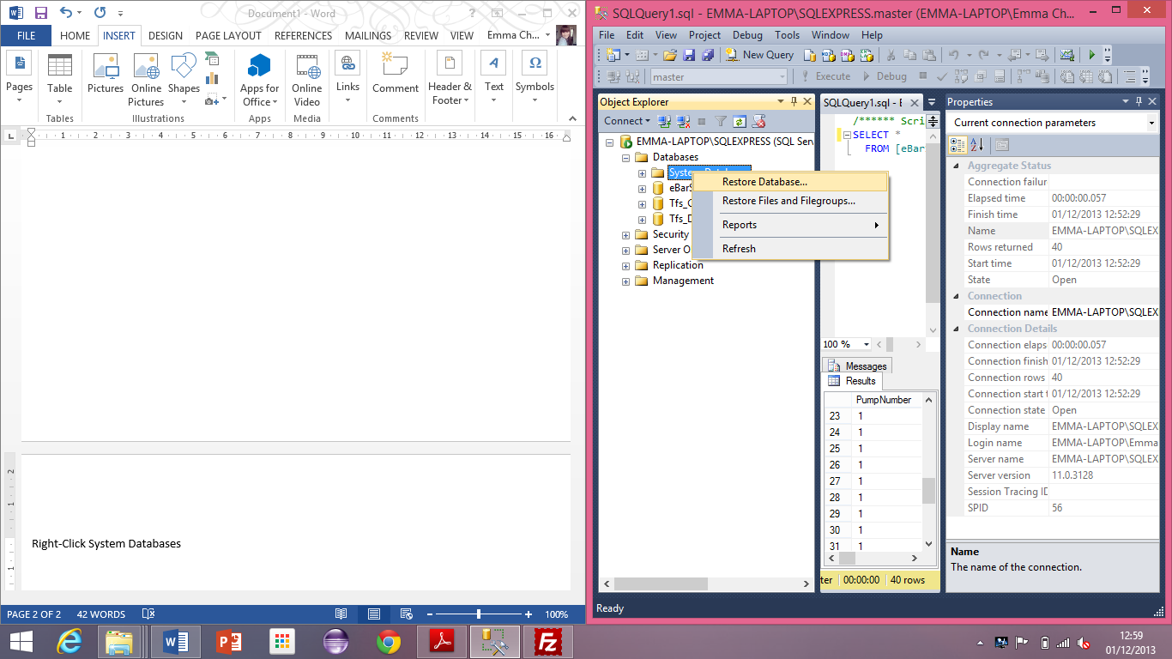

1. Click **Restore Database**
2. Select **Device** and click the **Ellipsis (…)**
3. Click **Add** and navigate to the location of eBarSystemsDatabase.bak

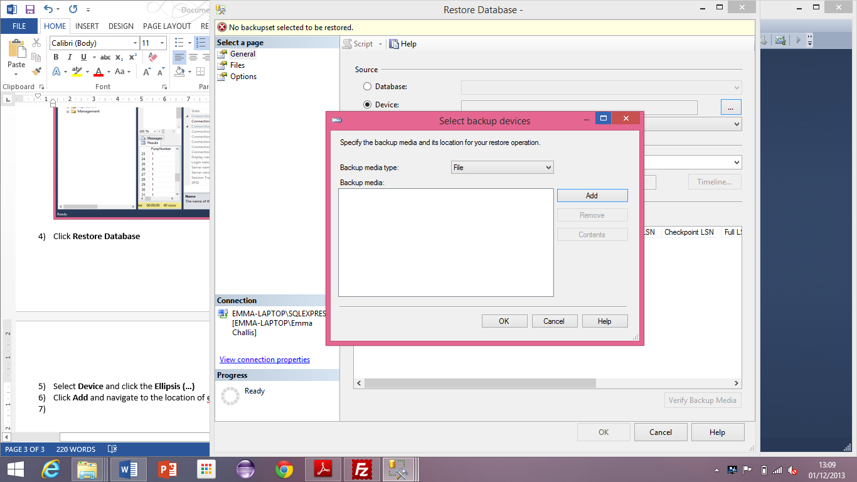

1. Click **Ok** and then **Ok** again, the database should be restored and will now display in SQL Management Studio

# Install eBar Systems Data Grabber Service

This installation guide is left blank due to the complexity of the installation and that in the event of any failure, the service will not display any information to aid the user. Please use the eBar Systems Data Grabber Console.

# Install eBar Systems Data Grabber Console

The console reflects the EXACT behavior that the eBar Systems Data Grabber Service does with the exception of displaying error information. The eBar Systems software is developed to work out of the box with each piece of software containing its own configuration guide. Please see the eBar Systems Configuration Guide on how to setup each piece of software.

1. Place the eBarSystemsDataGrabberServiceConsole on the desktop
2. Place the eBarSystemsDataGrabberServiceConsole CONFIG file on the desktop
3. Ensure the data in the CONFIG file is correct
4. Double click to run, if the CONFIG file is correct the database will connect successfully and data will be pulled from the webpage

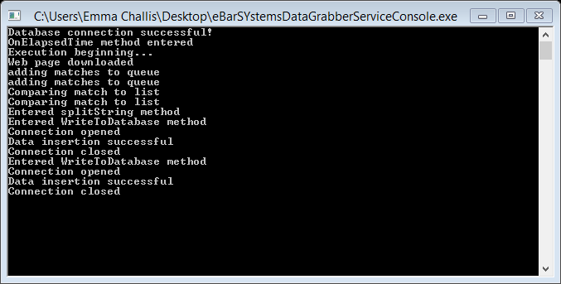

Note: Windows 8 may state that there is an issue with smart screen. Click more options and run anyway to get around this.

# Install eBar Systems Data Viewer (Currently called Till)

This system allows the user to view the logs created by eBar and search them. This software requires the database connection string to be correctly configured.

1. Place eBarSystemsTill on the desktop
2. Place eBarSystemsTill CONFIG on the desktop
3. Check the CONFIG file database is configured correctly
4. Run the software
5. Username = ABC123 and password = 12345 (If login fails, the database has not been configured correctly)